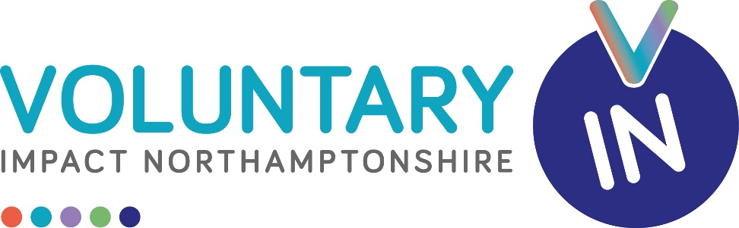
Being a Trustee at Voluntary Impact Northamptonshire (VIN)
Background:
Voluntary Impact Northamptonshire is a local charity and Infrastructure Organisation based in Northampton. It started life as a Volunteer Bureau and has developed over time to provide a range of services, including community advice, training, and support.
Voluntary Impact Northamptonshire is based at St Giles Street in Northampton and is also a Company Limited by Guarantee.
The current Trustee Board consist of 8 volunteers, and we are looking to increase that number.
For more information about our organisation please visit:
www.voluntaryimpact.org.uk
Trustees are required to attend on average 6 Meetings per Year plus the Annual AGM. These are currently held virtually via Zoom.
Role Specification:
A commitment to the mission of Voluntary Impact Northamptonshire.
A willingness to meet the minimum time requirement.
An ability to think creatively and strategically.
An ability to work as part of a Board.
An ability to make decisions which are often difficult and challenging.
The board of Trustees collectively need skills and experience in the following areas:
Fundraising.
Marketing.
Human Resources.
This should not preclude volunteers from applying who do not possess the above skill sets. Our constitution allows us a Board of 15 as a maximum.
General:
A basic induction is provided. For more information or an informal discussion please contact the VIN CEO on 07592 501770 or at Russell.rolph@voluntaryimpact.org.uk

